EXP NO: 11 Forensic examination of FAT32 Filesystem NAME : ADHIYAN PERIYAR R P

DATE: 11/09/2025 ROLL NO : 231901002

AIM :

Examine the FAT32 filesystem from a forensic point of view.

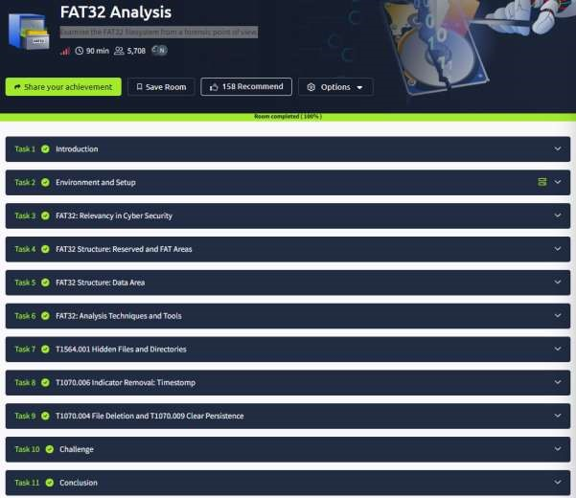

Task 1 : Introduction



Task 2 : Environment and Setup



Task 3 : FAT32: Relevancy in Cyber Security

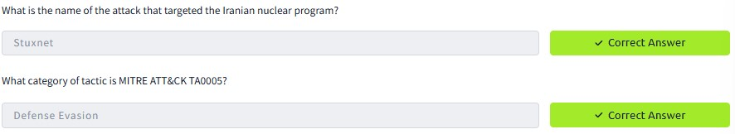

Task 4 : FAT32 Structure: Reserved and FAT Areas

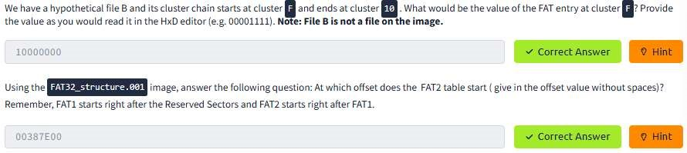

Task 5 : FAT32 Structure: Data Area

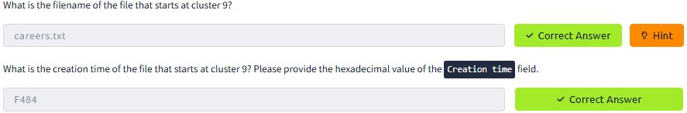

Task 6 : FAT32: Analysis Techniques and Tools



Task 7 : T1564.001 Hidden Files and Directories

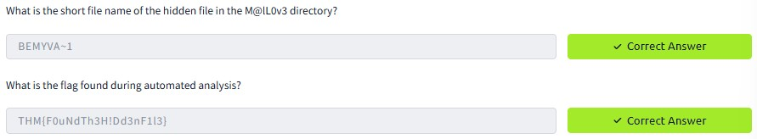

Task 8 : T1070.006 Indicator Removal: Timestomp

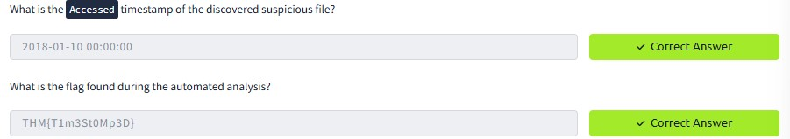

Task 9 : T1070.004 File Deletion and T1070.009 Clear Persistence

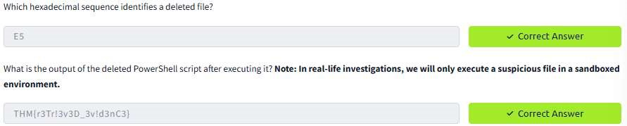

Task 10 : Challenge

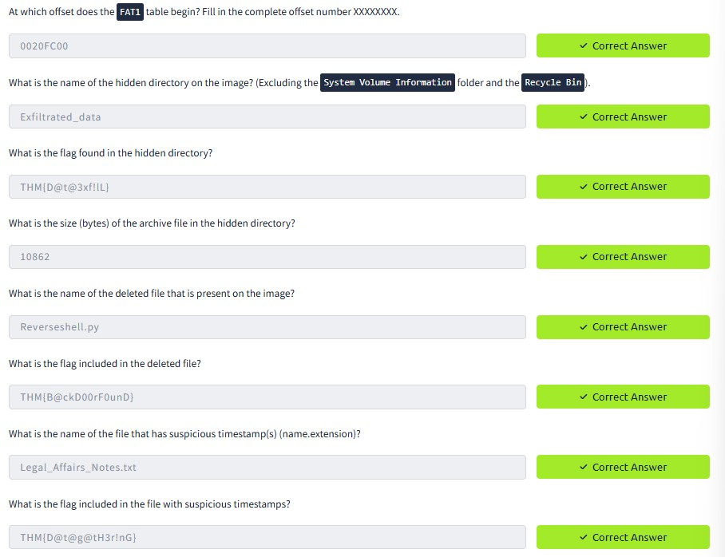

RESULT :

Forensic examination of FAT32 Filesystem is successfully completed in tryhackme platform.